DIE# 15191 – HPAC (EXTRUDER SIDE)
Green Buggy + Wrap arms with cardboard
USE FOAM AS SHOWN BELOW

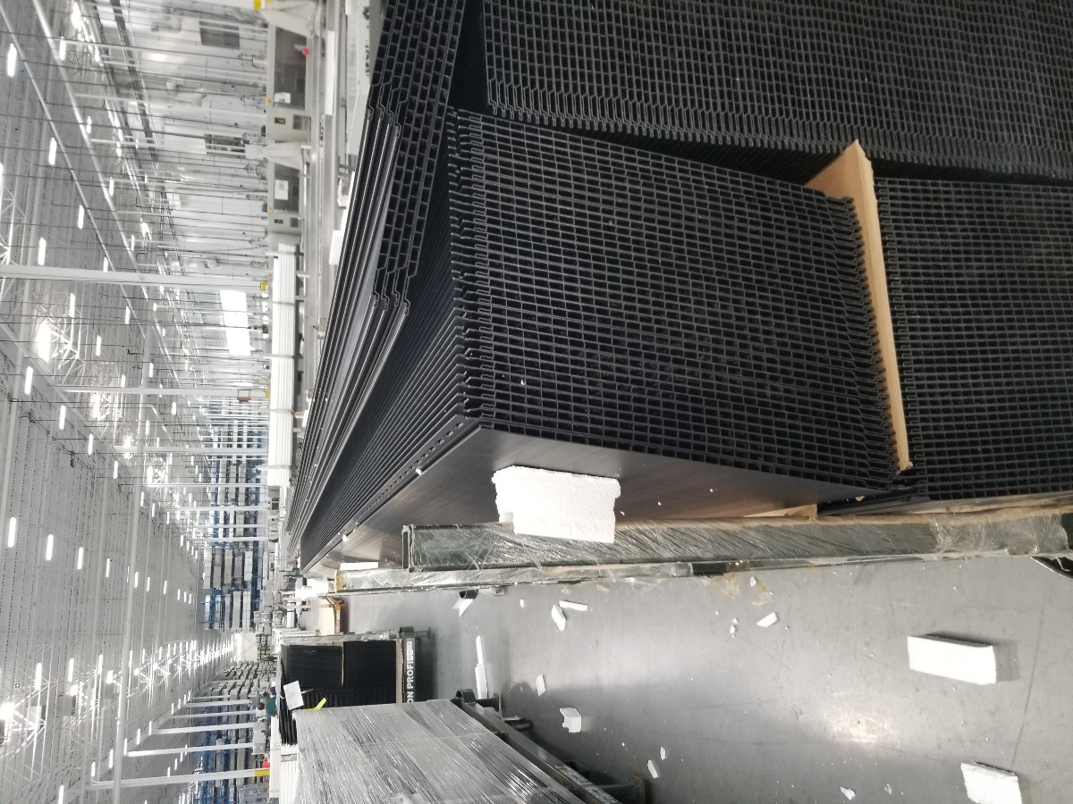
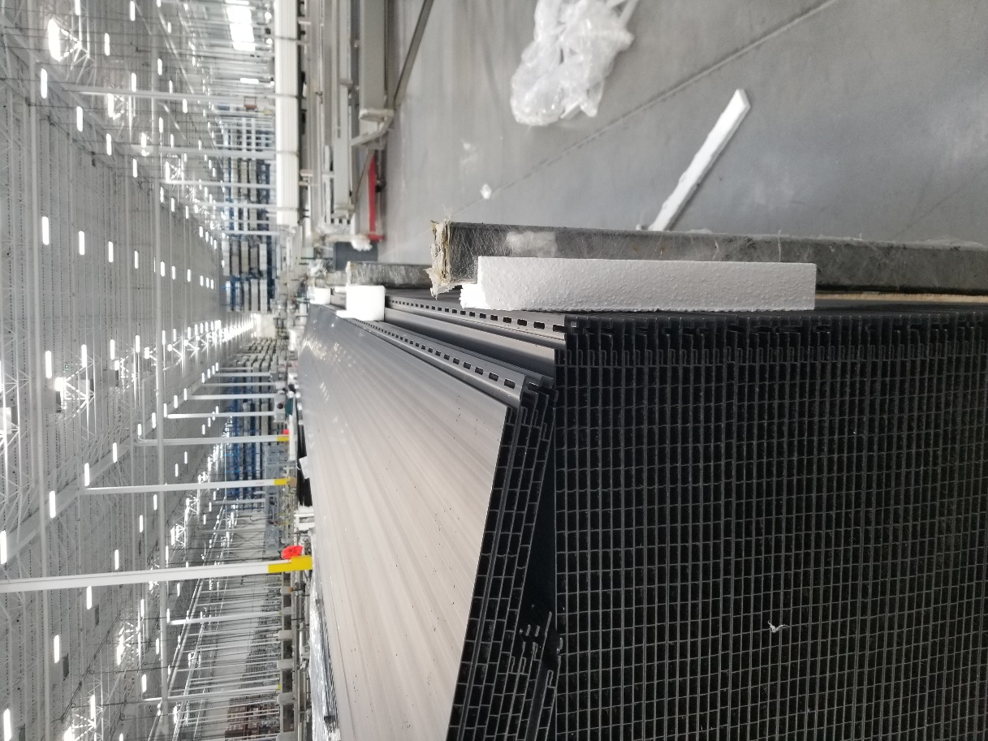
MAKE SURE WHEEL WILL NOT
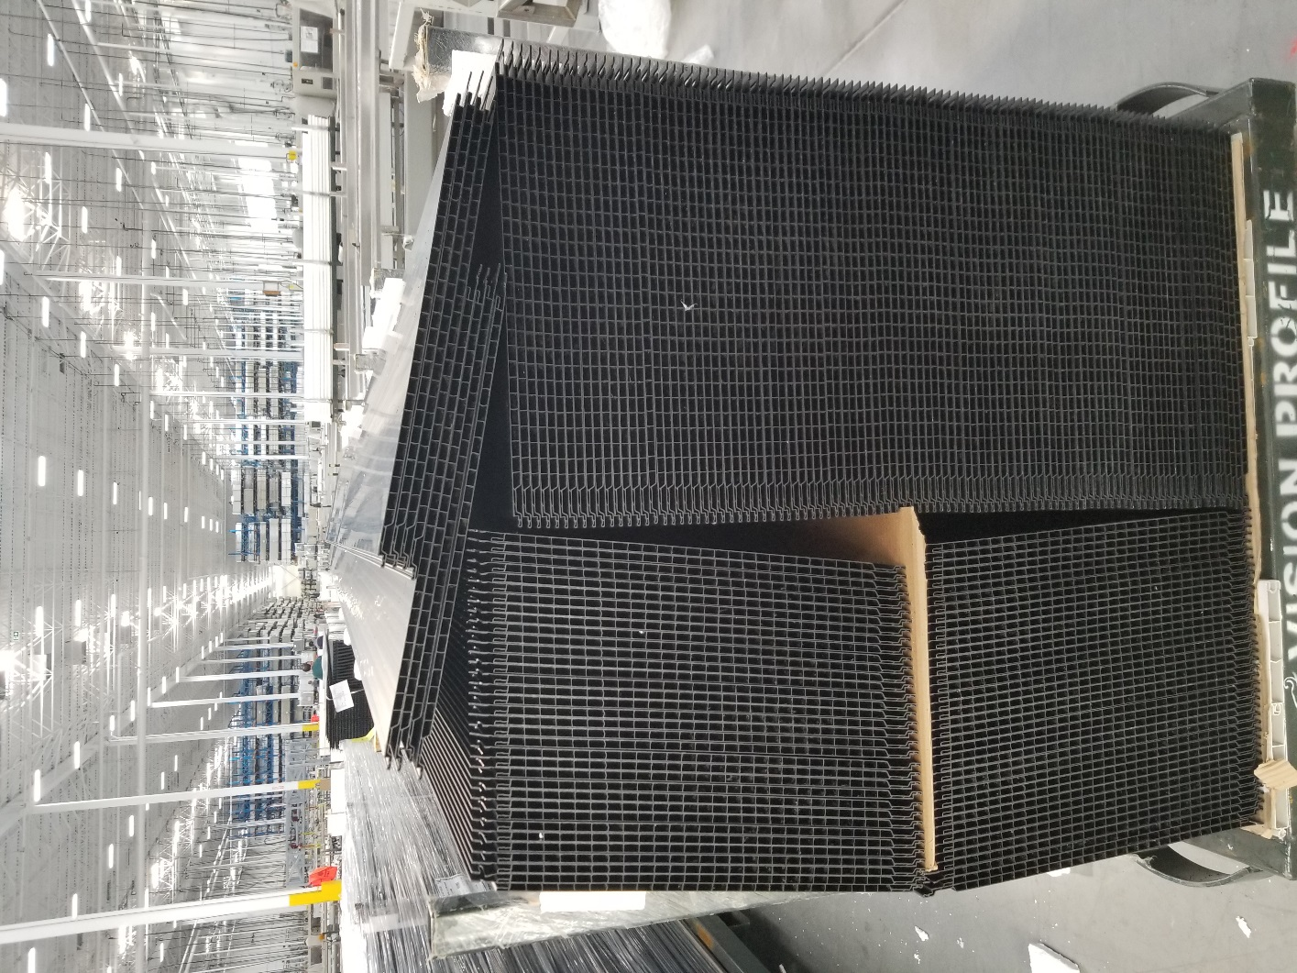
DAMAGE PIECES WHEN STACKED

